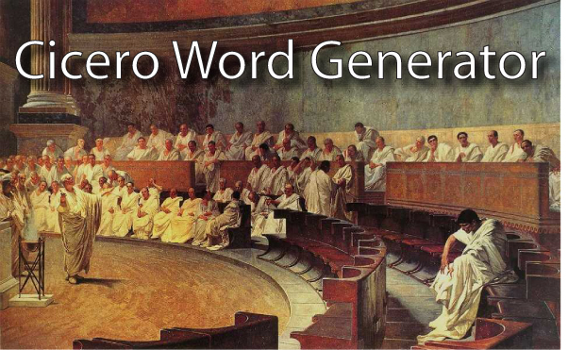

Overview of Changes to the Cicero Word Generator

Bigelow CAT group, University of Rochester, July 15, 2019

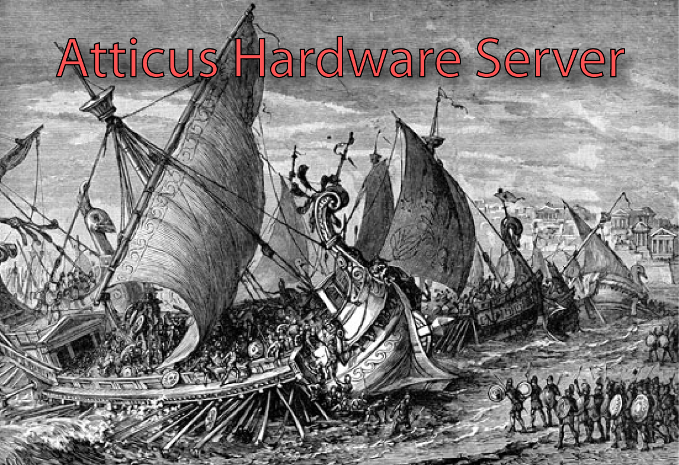

Introduction

This document describes the changes that were made to the Cicero Word Generator project by the Bigelow Cooling and Trapping (CAT) group at the University of Rochester in 2019. The purpose of this document is to layout the alterations that have been made to the user interface (UI), and to assist readers in learning how to use the new interface. The Cicero Technical and User Manual, available at https://github.com/akeshet/Cicero-Word-Generator, should be read before reading about the small changes that we have made to the interface. If you have any questions, comments, or suggestions, or if you discover any problems or bugs in the features described in this document, please feel free to contact ehaber@ur.rochester.edu!

When text appears in Courier, this indicates that the text is the name of an object or function as it appears in the software source code. When text appears in Boldface, this indicates that the text refers to a field or text label in the software’s user interface, or to a literal string such as a file name.

License and Warranty Information

The following copyright information applies to all the applications in the Cicero Word Generator suite:

Copyright (C) 2008, Aviv Keshet

This program is free software: you can redistribute it and/or modify it under the terms of the GNU General Public License as published by the Free Software Foundation, either version 3 of the License, or (at your option) any later version.

This program is distributed in the hope that it will be useful, but WITHOUT ANY WARRANTY; without even the implied warranty of MERCHANTABILITY or FITNESS FOR A PARTICULAR PURPOSE. See the GNU General Public License for more details.

For the full text of the of the GNU General Public License, see <http://www.gnu.org/licenses/>.

This Cicero Word Generator suite makes use of the .Math library to parse and evaluate user-entered equations. The following copyright notice applies to the .Math library:

Copyright (c) 2001-2004, Stephen Hebert
All rights reserved.

Redistribution and use in source and binary forms, with or without modification, are permitted provided that the following conditions are met:

Redistributions of source code must retain the above copyright notice, this list of conditions and the following disclaimer.

Redistributions in binary form must reproduce the above copyright notice, this list of conditions and the following disclaimer in the documentation and/or other materials provided with the distribution.

Neither the name of the .Math, nor the names of its contributors may be used to endorse or promote products derived from this software without specific prior written permission.

THIS SOFTWARE IS PROVIDED BY THE COPYRIGHT HOLDERS AND CONTRIBUTORS "AS IS" AND ANY EXPRESS OR IMPLIED WARRANTIES, INCLUDING, BUT NOT LIMITED TO, THE IMPLIED WARRANTIES OF MERCHANTABILITY AND FITNESS FOR A PARTICULAR PURPOSE ARE DISCLAIMED. IN NO EVENT SHALL THE COPYRIGHT OWNER OR CONTRIBUTORS BE LIABLE FOR ANY DIRECT, INDIRECT, INCIDENTAL, SPECIAL, EXEMPLARY, OR CONSEQUENTIAL DAMAGES (INCLUDING, BUT NOT LIMITED TO, PROCUREMENT OF SUBSTITUTE GOODS OR SERVICES; LOSS OF USE, DATA, OR PROFITS; OR BUSINESS INTERRUPTION) HOWEVER CAUSED AND ON ANY THEORY OF LIABILITY, WHETHER IN CONTRACT, STRICT LIABILITY, OR TORT (INCLUDING NEGLIGENCE OR OTHERWISE) ARISING IN ANY WAY OUT OF THE USE OF THIS SOFTWARE, EVEN IF ADVISED OF THE POSSIBILITY OF SUCH DAMAGE.

Changes to Atticus

The two primary changes that have been made to Atticus are discussed in this section.

Opening Atticus

When the new version of Cicero is opened, it will also attempt to open Atticus using the filepath saved in memory. If this is your first-time opening Cicero, or you have changed where Atticus is located, then it will ask you to locate Atticus yourself so that it can automatically open it in the future. If you would prefer to not have Cicero open Atticus upon startup, you can disable this functionality by clicking on the checkbox at the bottom of the Sequence tab labelled Open Atticus server at startup? in Cicero.

Analog Input Tests

The ability to perform Boolean tests on analog input channels prior to running any sequence in Cicero has been added to this software. To setup a channel to be tested before each sequence run, go under the Analog In header in Atticus and modify the AI Channels collection. When you have selected a member of this collection, three controls have been added located under the Misc tab.

The ComparisonType allows you to select the type of comparison (>, <, ≥, ≤) to be performed, ComparisonValue sets the value that the channel will be compared to, and when DoComparison is set to true this channel will be compared to the chosen value before each sequence is run. The test that is performed is: (channelValue) (comparisonType) (comparisonValue).

Note that these controls are completely independent of the existing analog input controls in Atticus. For instance, a channel could be used to perform a test before a sequence run without also saving its input data during the run. The remaining details regarding analog input tests are discussed in the Channel Manager section below.

Changes to Cicero

In this section, the main changes that have been made to Cicero are outlined.

Server Manager

The server manager has been modified so that it no longer automatically stops pinging a server after a set time, but instead will continue pinging until the user presses the Stop pinging server button.
Channel Manager

Several changes have been made to the channel manager. When a channel is being added or edited, there is now a checkbox labelled Turn off the channel if AI check fails? When this is checked, the channel will be turned off if any AI check fails before a sequence is run (i.e. Cicero will not use this channel if an AI check fails). Channels that don’t have this box checked will still be used even if the AI check fails.

The other control that has been added to the add/edit logical device editors is a dropdown menu labelled ‘Ordering group:’ that allows you to assign this channel to an ordering group. Ordering groups are described in the Ordering Lists section of this document. This section also describes the Ordering group controls that have been added to the rightmost panel of the channel manager.

Pulses

The ability to create sequences using pulses has been expanded in this version of Cicero. In addition to building up sequences using timesteps, the user can now create entire sequences just using pulses. Several new controls have been added to the pulses tab to allow for this.

The first is a dropdown box on the leftmost panel of the page that displays all the modes in the current sequence. The new types of pulses in this version of Cicero belong to a specific mode, and only pulses within the selected mode will be displayed. The other new controls on this panel can be used to sort the displayed pulses. These controls are described in the Ordering Lists section of this document.

When a new pulse is created, the user must select what type of pulse it will be using the pulse editor. OldDigital pulses are identical to the old version of pulses as described in the Cicero Technical and User Manual. Analog, Digital, and GPIB pulses are new types that will write to analog, digital, or GPIB channels respectively during the pulse. This is similar to how OldDigital pulses will write to digital channels during the pulse. The new pulses, however, give the user greater freedom in selecting when the pulse will begin and end. Mode pulses are also new and will be explained later in this section. Regardless of the type of pulse, each editor has an arrow button in its top left corner. When clicked the button resizes the editor to either display all its controls, or to hide all the controls that come below the Description textbox.

Like OldDigital pulses, the new pulses must have start and end conditions. The possible choices for each are the beginning or end of another pulse, or the beginning or end of the entire sequence. A pretrigger or delay time can also be used. The user should be wary of choosing improper start and/or end conditions of pulses. For instance, no pulse can start or end before the sequence begins, or after the sequence ends. Additionally, every pulse must ultimately have its start and end conditions link back to either the start or end of the sequence (i.e. you could not have pulse A’s start and end conditions both refer to pulse B if pulse B’s start and end conditions each refer to pulse A!). This ensures that actual values can be assigned to each pulse’s start and end times when the pulses are being translated into timesteps to build the sequence. These errors will be checked for by Cicero before it allows the user to build a sequence using the Update Sequence button in the leftmost panel.

For new pulses, the pulse’s group tells Cicero what the channel selected for that pulse should do while the pulse is asserted. For Analog and GPIB pulses, the groups that can be chosen are, naturally, analog and GPIB groups, respectively. The waveform corresponding to that group and channel number is displayed on the right side of the pulse editor. For Digital pulses, the group can be set to On or Off to turn the digital channel on or off during the pulse, or the group can be set to be a variable. If the variable’s value is zero then the channel will be turned off during the pulse, and if the variable is nonzero then the channel will be turned on.

The mode of the pulse determines which sequence mode the pulse belongs to. In the leftmost panel of the Pulses tab there is a dropdown menu underneath the Autoname Glossary button that allows the user to select a sequence mode. Only pulses that belong to the selected sequence mode will be displayed. When a sequence is built using pulses (as described later in this section) the pulses will be broken down into timesteps, and the timesteps corresponding to each pulse will belong to the same sequence mode as the pulse does.

If the Disable pulse checkbox is clicked, then all the pulse’s controls other than the disable button itself and the resize button in the upper left side of the pulse editor will be disabled in the UI. To change the ordering group of the pulse, the dropdown menu and Remove button located below the Disable pulse checkbox can be used (see Ordering Lists section for more information).

A Mode pulse does not tell a single channel what to do during some time interval, but instead is a reference to the pulses of another sequence mode. While a mode pulse is asserted, the sequence mode it references will be run (i.e. all the pulses in that mode will be run). This allows the user to have one or more sequence modes run from inside of another sequence mode. The Display pulses checkbox will display copies of each pulse that belongs in the imported mode. The imported pulses will be colored blue (to distinguish them from regular pulses), unless they are invalid, in which case they will be colored red. This is just for show, however, as all the controls of the imported pulses will be disabled. Only the pulses in the original sequence mode can be edited. These edits will also affect any copies of the pulses that have been imported to other modes.

Finally, pulses which are found to contain an error will have a red colored background and have a short (hopefully helpful!) description of the problem displayed in the lower right side of the pulse editor. Most error checks are performed while the user is changing the pulse editor. Errors related to the start and end times of the pulse are only checked for after the user presses the Update Sequence button.

Unlike OldDigital pulses, the new pulses are used to build sequences when the Update Sequence button is pressed. It will replace the currently displayed timesteps with new timesteps that implement the pulses. Note that all existing timesteps, other than Rest values and Output now (described below), will be deleted! To do this, Cicero will divide the pulses up into timesteps, and label the new timesteps with the names of each pulse that is active during that timestep. And, since pulses may span across multiple timesteps, a number in square brackets will also be displayed next to each pulse name to indicate how many timesteps the pulse has been active for. If an analog or GPIB channel has no active pulses during a timestep then it will be set to Continue, digital channels will be set to off. Timesteps corresponding to different modes will be set to be inactive and invisible when sequences are built using the Update Sequence button.

Two new timesteps with lengths of zero will be created at the beginning of the sequence (if they don’t already exist) when the Update Sequence button is pressed. The first is labelled Rest values, and the value of each channel in this timestep will be the value that the channel returns to after the sequence runs (described in the Cicero Technical and User Manual as a dwell word). The second timestep of length zero is labelled Output now, and it is added for the user’s convenience (output now is also described in the Cicero Technical and User Manual). These timesteps are the only ones that will not be destroyed or changed when the Update Sequence button is used. They will also be visible and enabled in each sequence mode.

Run Modes

A new tab labelled Run Modes has been added to Cicero. The page layout is similar to the pulses tab, and it allows the user to create and run mode lists. Running a mode list allows the user to easily run different modes one after the other with arbitrary time intervals between each.

The Create new list button will create a new mode list editor. To populate the list with sequence modes, the first dropdown menu in the editor will display all the sequence modes that currently exist. The Add mode to list button will add the currently selected sequence mode to the end of the mode list of this editor. A blue box with the name of the mode will appear, along with a box that allows you to add in a delay between this mode and the next mode in the list.

Clicking on a mode in a list will select the mode and turn the box green. All buttons in the mode list editor that refer to selected modes refer to modes in the list that have been clicked on. Copy selected modes, for instance, will copy only modes whose boxes are green. By contrast, Copy list will copy all modes in the list, selected or not. The different copy and paste buttons can be used to copy modes from one list and then paste them into any list (same as original one, or different).

The font size of the displayed mode names of each button within a list can be changed using the rightmost numeric control in the editor. If ordering group’s for mode lists have been created using the controls on the left panel of the page, then a mode list editor can be added to and removed from ordering groups using the rightmost dropdown menu in the mode list editor. These controls are described in the Ordering Lists section of this document.

Finally, to run a mode list from the Sequence page, select a mode list from the dropdown menu located beneath the Run mode list button, and then click the Run mode list button to run all the modes in that list sequentially just like you would ordinarily run a single sequence mode.

Autoset Dwell Words

A new checkbox has been added to the Sequence tab labelled Autoset dwell words. When this box is checked, the dwell word for each analog and digital channel will automatically be set to that channel’s final value in the sequence being run. This is done whenever one of the run buttons is clicked (dwell words are described in the Cicero Technical and User Manual).

To do this, Cicero will create a 0s-long timestep at the beginning of the sequence named Rest values. If the first enabled timestep in the sequence is already named Rest values, it will be overwritten. This timestep will have an analog group, named Rest values, where each channel is set to be that channel’s final value in the current sequence mode. Similarly, the digital channels in this timestep will be turned on or off depending on whether they are on or off at the end of the sequence.

The final value for each channel is found by iterating backwards through the enabled timesteps in the sequence and looking for the first one that is not set to Continue. For analog channels, the value of the waveform at the end of the channel’s last enabled timestep is taken as that channel’s final value.

Ordering Lists

In the previous version of Cicero, most lists of objects in the UI were permanently ordered according to their creation time. This version has been updated with controls for many of these lists that allow the user some freedom in how to sort them. Hardware channels in the channel manager, sequence modes, analog groups, variables, pulses, and list modes all allow the user to sort these lists. For everything except sequence modes and analog groups, these controls are displayed under the banner Ordering group controls: and are located near to where the objects are created (ex. for sequence modes the control is located just below the textbox for naming the mode in the Sequence tab).

Each of these lists can be sorted by creation time (i.e. how Cicero usually sorts it), or alphabetically. The sorting method can be chosen from a new dropdown menu that has a pop-up help window with the text Select a sorting method for the, followed by the name of the object. Additionally, pulses can be sorted according to the starting time of the pulse relative to all other pulses in that sequence mode.

Finally, hardware channels, variables, pulses, and list modes all allow the user to create ordering groups. The ordering group controls for these objects include a checkbox labelled Organize [object name]s by group, checking this box will place the objects into different ordering groups (that are created by the user) before sorting each group according to the chosen method. So that, when the objects are displayed, they will be listed under their respective sorting group, and all the objects within that group will be sorted by the chosen method.

Similar to how sequence modes are created, the textbox underneath the Ordering group controls: header can be used to name a new sorting group, the create button will create a new group with the given name, the dropdown menu can be used to select an existing group, and the delete button will delete the selected ordering group. The hardware channel, variable, pulse, and mode list editors each contain controls for adding the object being edited to an ordering group (or moving it to another group). If a list is sorted and not all the objects in it have been added to an ordering group, then they will be placed at the top of the list. Ordering groups will be ranked alphabetically (i.e. objects in a group named ‘A’ will appear earlier in the list than those in a group named ‘B,’ regardless of the sorting method being used on the objects themselves is).

Saving Cicero Settings

New options for saving information in Cicero and Atticus have been added. To select a folder for storing this additional backup information, click the Browse for savefile path: button in the Sequence tab. This will allow you to select a place to store the CiceroBackupSettings folder. Within this folder, Cicero will create subfolders for the year, month, and day, and within each day folder subfolders labelled AtticusSettings, CiceroSettings, and Pulses will be created.

Every time a sequence is run the corresponding Cicero sequence and settings data will be saved in the CiceroSettings folder as .seq and .set files. Each file will also have a name that ends with the time (hours, minutes, and seconds) it was created. Similarly, the Atticus settings data will be stored in the AtticusSettings folder before each run.

Information can be stored in the Pulses folder using the Save settings button in the Sequence tab. When clicked, this button will create a text file in the Pulses folder corresponding to the current date and labelled according to the current time. The text file stores all information necessary to recreate the pulses (excluding OldDigital) in the current sequence in human-readable form. For each sequence mode it will list all the pulses within that mode, and for each pulse all its parameters (i.e. type, channel, start condition and delay, end condition and delay, waveform, etc.). Additionally, the text file will contain a list of all variables, common waveforms, and hardware channels that are being used.

